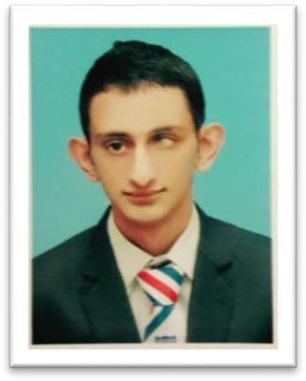Junaid Shahid

**10 July 1995**

# Address: Al Rigga, Dubai - UAE Email: [Junaidshahid910@gmail.com](mailto:Junaidshahid910@gmail.com)

**Visa Status: Visit Visa Mobile: +971 50 209 6520**

**OVERVIEW Hospitality professional with 1 year experience**

I am a Hospitality Professional with a Graduate Diploma in Hospitality & Tourism Management. I have 1.8 years of experience at three reputable Hospitality organizations. My strengths include, Building Connections, Efficient problem solving. Enthusiasm, Commitment, Organized and Thorough I am looking for a full- time position in Hospitality industry**.**

# WORK EXPERIENCE Sales & Marketing Executive

FALCON ADVENTURE CLUB, ISLAMABAD, PAKISTAN

***May 2018 – Sep 2019***

**Key responsibilities included:**

* Identify Key marketing opportunities and advertise/market new offers from company on all mediums especially on social media
* Carrying out effective research & intelligence into competitor products & other trends.
* Tomakeproposals for the customized events for individual and corporate clients.

# Food & Beverage Trainee

PEARL CONTINENTAL HOTELS & RESORTS, RAWALPINDI, PAKISTAN

***Feb 2018 – March 2018***

**Key responsibilities included:**

**Food & Beverage Operations**

* **2 weeks of experience in Food & Beverage Operations**
* Maintained knowledge of current menu items garnishes ingredients and preparation methods.
* Set tables in assigned area, or check to see that they have been set correctly and uniformly using clean pressed linen, clean unspotted silverware; clean china, clean unspotted glassware.
* Deliver exceptional service by greeting and serving customers in a timely friendly manner.

# Banquet Sales & Operations

* **6 weeks of experience in Banquet Sales & Operations**
* Provided administrative and general support to both the sales and catering team.
* Communicate and collaborate all event details with a variety of departments within the hotel operation.
* Responsible for multitasking at multiple events and daily operation

# Housekeeping Trainee

GRAND AMBASSADOR HOTEL, ISLAMABAD, PAKISTAN

# Dec 2017 – Jan 2018

**Key responsibilities included:**

* **4 Weeks of experience in Housekeeping**
* Replenish stock of items in hotel rooms
* Monitor rooms for general repairs and upkeep
* Inspect guest rooms prior to checking in
* Accommodate requests by guests for extra towels, ice bucket, pillows and blankets

# QUALIFICATIONS Graduate Diploma in Hospitality & Tourism Management

COLLEGE OF TOURISM & HOTEL MANAGEMENT - COTHM, ISLMABAD, PAKISTAN

# 2016 – 17

**Coursework:** Hospitality & Tourism Management, F&B Operations, H&T Marketing, Mastering Communications, Front Office Operations, Human Resources, Accounting

**Intermediate in Commerce (HSSC)** SUPERIOR COLLEGE, BUREWALA, PAKISTAN **2014 – 2016**

# Matriculation in Science (SSC)

DIVISIONAL PUBLIC SCHOOL, BUREWALA, PAKISTAN

# 2011 – 2013

**SKILLS**

* **Soft Skills**

Interpersonal Skill, Communication Skill, Problem Solving

Team Management, Facilitating Skill, Presentation Skill, Confident

# Computer Skills

Microsoft Word, PowerPoint, Excel, Internet

# Language Skills

English, Urdu

**INTERESTS** Culinary Arts Bartender Barista

Event Planning Interior Designing

**REFERENCES** Will be provided on demand